**IFRS 16**

**1. Background**

* IFRS 16 supersedes IAS 17 Leases (and related Interpretations) and is effective from 1 January 2019.
* The IASB and the US national standard-setter, the Financial Accounting Standards Board (FASB), have been working jointly to improve the accounting for leases in International Financial Reporting Standards (IFRS) and US Generally Accepted Accounting Principles (US GAAP).
* IFRS 16 completes the IASB’s project to improve financial reporting for leases.

**2.Objective of IFRS 16**

The premise of IFRS 16 is simple: to bring all companies’ leases onto their balance sheets for 2019 accounting periods onwards.

***The objective of IFRS 16 is to report information that***

***(a) faithfully represents lease transactions and***

***(b) provides a basis for users of financial statements to assess the amount, timing and uncertainty of cash flows arising from leases.***

To meet that objective, a lessee should recognise assets and liabilities arising from a lease.

* IFRS 16 introduces a single lessee accounting model and requires a lessee to recognise assets and liabilities for all leases with a term of more than 12 months, unless the underlying asset is of low value.
* A lessee is required to recognise a right-of-use asset representing its right to use the underlying leased asset and a lease liability representing its obligation to make lease payments.

**3.Scope of IFRS 16**

* The scope of IFRS 16 is generally similar to IAS 17 and includes all contracts that convey the right to use an asset for a period of time in exchange for consideration, except for licences of intellectual property granted by a lessor, rights held by a lessee under licensing agreements (such as motion picture films, video recordings, plays, manuscripts, patents and copyrights), leases of biological assets, service concession agreements and leases to explore for or use minerals, oil, natural gas and similar non-regenerative resources.
* There is an optional scope exemption for lessees of intangible assets other than the licences mentioned above
* IFRS 16 includes detailed guidance to help companies assess whether a contract contains a lease or a service, or both.
* Under current guidance and practice, there is not a lot of emphasis on the distinction between a service or an operating lease, as this often does not change the accounting treatment.
* The analysis starts by determining if a contract meets the definition of a lease.
* This means that the customer has the right to control the use of an identifiable asset for a period of time in exchange for consideration.

**4.Key Changes because of IFRS 16**

* The key elements of the new standard and the effect on financial statements are as follows:
* A ‘**right-of-use**’ model replaces the ‘**risks and rewards’** model. Lessees are required to recognise an asset and liability at the inception of a lease.
* All lease liabilities are to be measured with reference to **an estimate of the lease term**, which includes optional lease periods when an entity is reasonably certain to exercise an option to extend (or not to terminate) a lease.
* **Contingent rentals or variable lease payments** will need to be included in the measurement of lease assets and liabilities when these depend on an index or a rate or where in substance they are fixed payments.
* A lessee should reassess variable lease payments that depend on an index or a rate when the lessee re-measures the lease liability for other reasons and **when there is a change in the cash flows resulting from a change in the reference index or rate**
* Lessees **should reassess the lease term** only upon the occurrence of a significant event or a significant change in circumstances that are within the control of the lessee.

**5.How the Various Items in Financial Statements Will be Affected ?**

* The new standard will affect virtually all commonly used financial ratios and performance metrics such as **gearing, current ratio, asset turnover, interest cover, EBITDA, EBIT, operating profit, net income, EPS, ROCE, ROE and operating cash flows.**
* These changes may affect loan covenants, credit ratings and borrowing costs, and could result in other behavioural changes.
* These impacts may compel many organisations **to reassess certain ‘lease versus buy’ decisions.**
* Balance sheets will **grow**, gearing ratios will increase, and capital ratios will decrease.
* There will also be a change to both **the expense character** (rent expenses replaced with depreciation and interest expense) and **recognition pattern** (acceleration of lease expense relative to the recognition pattern for operating leases today).
* Entities leasing ‘**big-ticket’ assets** – including real estate, manufacturing equipment, aircraft, trains, ships, and technology – are expected to be greatly affected.
* Low value assets meeting this **exemption** do not have to be recognised on the balance sheet
* The cost to implement and continue to comply with the new leases standard could **be significant for most lessees**. Particularly if they do not already have an in-house lease information system.

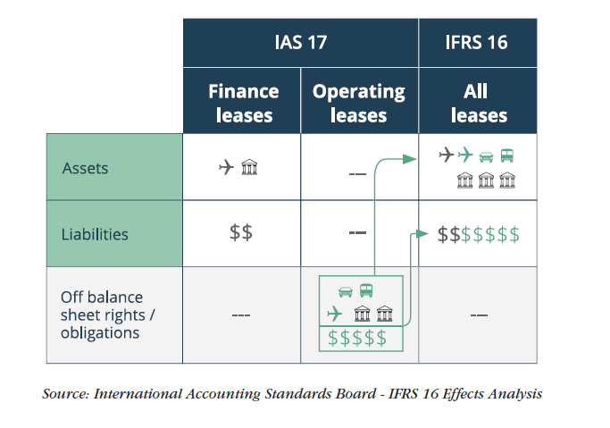

**Easy Diagram-Based Explanation**

* **Impact on Balance Sheet**
* 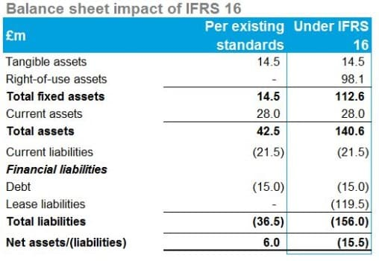Adoption of IFSR 16 results in a material increase in assets and liabilities, but with a net increase in liabilities, resulting in a move from an overall net asset position to a net liability position.
* 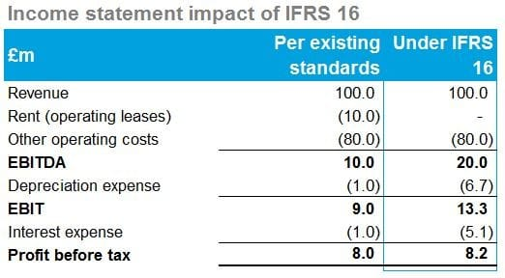Lease liabilities will be classified as financial liabilities, and therefore will impact reported financial indebtedness, balance sheet ratios and covenants.
* **Impact on   
  Income Statement**
* Overall there is a limited impact on reported profit before tax, but EBITDA and EBIT are increased materially, with property lease costs now being shown as depreciation and interest expenses.
* This will impact on banking covenants and leverage ratios derived from standard income statement measures such as EBITDA and EBIT..

**6.Impact of IFRS 16 On Retail Industry**

Although virtually every industry uses leasing as a means to obtain access to assets, the type and volume of assets that they lease, and the terms and structures of these lease agreements differ significantly

**Retail Sector**

Retaily industry majorly uses leases for their stores. They are likely to experience major impacts when implementing the new leases standard:

* **Renewal options** – leasing real estate is retailers’ core business and determining and reassessing when a retailer has an economic incentive to renew a retail lease location may require substantial judgement.
* **Variable payments linked to index or rate** – retailers need to put systems in place to estimate and remeasure variable payments linked to an index at the spot rate for each reporting period (e.g. CPI).

Separating lease and non-lease elements – retailers will need to separate service charges (e.g. administrative/utilities/marketing) from lease elements with many landlords – for example, with shop-in-shop leases and large retail outlets

**7. IFRS 16 Impact on Individual Retail Companies in Europe**

|  |  |  |  |  |
| --- | --- | --- | --- | --- |
| Key Balance Sheet Elements Comparison  (€ million) or % Change over previous year | Morrisons (FY/19) | Tesco Plc (FY/19) | Alhord Delhaize(Q1/19) | Casino Groupe (H1/19) |
| Right-of-use assets | 929 | 7,527 | 7,027 | 4,982 |
| Current assets | 8.8% | -1% | 1% | 1% |
| Total assets | 7.6% | 13% | 19% | 14% |
| Total equity | -6.6% | -12% | -4% | -3% |
| Non-current financial liabilities | 1.6% | -2% | 4% | -0.41% |
| Total equity and liabilities | -6.6% | -12% | 19% | 14% |

**Balance Sheet Observations**

1.As we can observe the Right-Of-Use Assets sections which has been added to each of the following companies balance sheet has increased the Assets by that amount which has also led to changes in

-An Increase in Total Assets for all of the companies   
-An Overall effect of change on Total Equity and Liabilities

|  |  |  |  |  |
| --- | --- | --- | --- | --- |
| Income Statement Element Comparison (€ million) or % Change over previous year | Morrisons (FY/19) | Tesco Plc (FY/19) | Alhord Delhaize(Q1/19) | Casino Groupe (H1/19) |
| Revenue | 0.00% | 0% | 0.0% | 0% |
| COGS | -0.26% | -1% | 0.0% | -0.24% |
| Operating Proft | 9.64% | 23% | 8.5% | 25.7% |
| Finance Cost | 57.73% | 103% | 87.5% | 82.5% |
| Finance Income | 4.55% | 14% | 200.0% | -1.9% |
| Tax | -7.89% | -2% | -1.9% | -34.8% |

2 .A Change in the non-current financial liabilities section of the companies ,this impact is majorly dependent upon the lease liabilities which a company has and varies company to company according to it.

|  |  |  |  |  |
| --- | --- | --- | --- | --- |
| Key Metrics for Cash Flow (€ million) or % Change over previous year | Morrisons (FY/19) | Tesco Plc (FY/19) | Alhord Delhaize(Q1/19) | Casino Groupe (H1/19) |
| CFO | 16% | 18.2% | -1.0% | -14% |
| Lease Payment | 122% | 193.3% | -44.4% | 35% |
| Repayment of New or Extra Lease Obligations under IFRS 16 | +69 | +588 | +320 | +343 |

**Cash Flow Observations**

1.An Decrease/Increase in the CF from Operations can be attributed to the payment for leases which were earlier made under the Core Operating Expenses

2.An Increase in the Lease Payments amount is because of the IFRS 16 leases expense recognition clauses

3.Extra Lease Obligation has been added in the CFS of every company as an impact of IFRS 16.

**Income Statement Observations**

1. No Impact on Revenue
2. As observed by the table ,COGS have been reduced by a -1% to 0.24% range ,which can be used to draw a conclusion that would also follow to a higher G/P number which may lead to better Margins for majority of the players.
3. Operating Profit has increased from 8.5% to 25.7% ,as an impact of Lease as an expenses removed from the Operating Expenses which leads to high Operating Margins
4. Finance Cost and Income has seen an increase because of the firms accounting lease payments received or expensed under this head which were earlier kept off balance sheet.